1.INTRODUCTION

* 1. Overview

I design a Resume using thia canva.

That was very easy to use. Anyone to use this canva easier.

* 1. Purpose

My project is creating a resume.

I create a resume using this canva

2. PROBLEMS DEFINITION & DESIGN THINKING

2.1 Empathy Map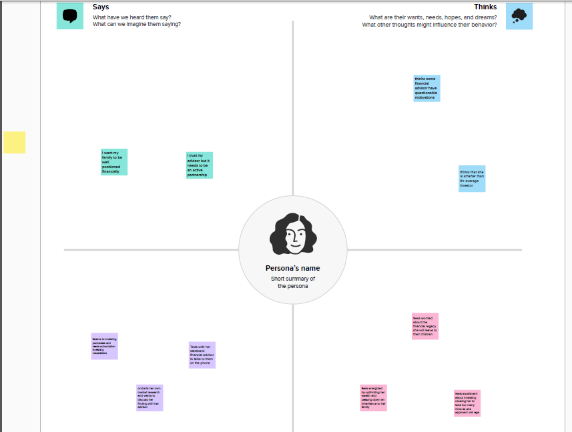

2.2 Brainstrom and idea prioritization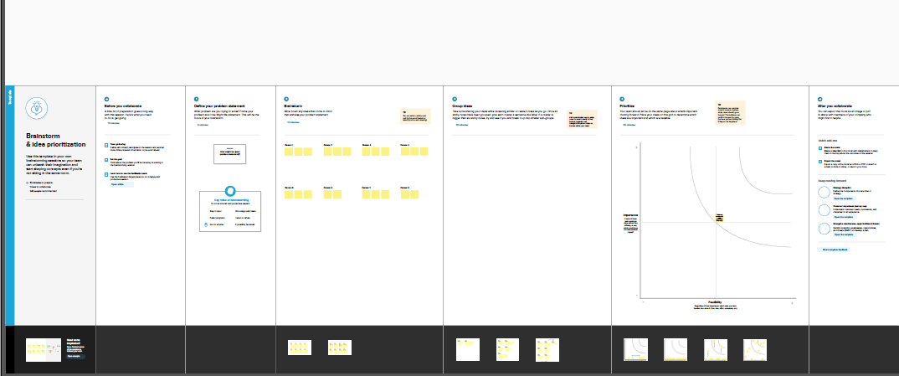

3.RESULT

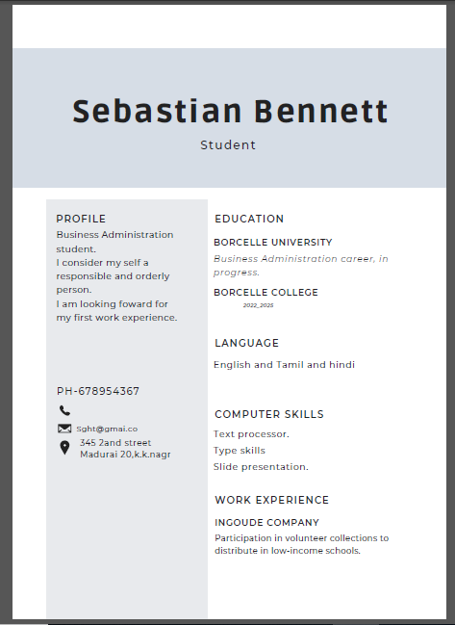

4.ADVANTAGES AND DISADVANTAGES

Easily to using this canva.

Freshers can easily to design anything in this canva.

I have data issues while using canva.

Canva was very useful to everyone.

5. CONCLUSION

I easily finish my project Resume. Canva is the most useful and best app for the freshers. Because, that has many templetes that was easy to use.